Assignment #3

Question #1:

#include<iostream>

using namespace std;

int main()

{

double square,cube; /*Here we are iniliazeing an array of size 50*/

double arr[50] = { 0.0,1.0,2.0,3.0,4.0,5.0,6.0,7.0,8.0,9.0,10.0,11.0,12.0,13.0,14.0,15.0,16.0,17.0,18.0,19.0,20.0,21.0,22.0,23.0,24.0,25.0,26.0,27.0,28.0,29.0,30.0,31.0,32.0,33.0,34.0,35.0,36.0,37.0,38.0,39.0,40.0,41.0,42.0,43.0,44.0,45.0,46.0,47.0,48.0,49.0 };

cout << "The Squares of above index is:" << endl;

for (int i = 0.0; i<=25.0; i++) /*this for loop will display the squares of indexes*/

{

if (i == 10||i==20)/*This is condition for break the line when index will ten*/

cout << endl;

else

cout << i*i << " ";

}

cout << endl;

cout << "The cubes of above index are :" << endl; /*THis for loop will display the cubes of indexes*/

for (int i = 26.0; i <=49.0; i++)

{

if (i == 10 || i == 20) /*This is condition for break the line when index will ten*/

{

cout << endl;

}

else

cout << i*i*i << " ";

}

cout << endl;

system("pause");

return 0;

}

Output

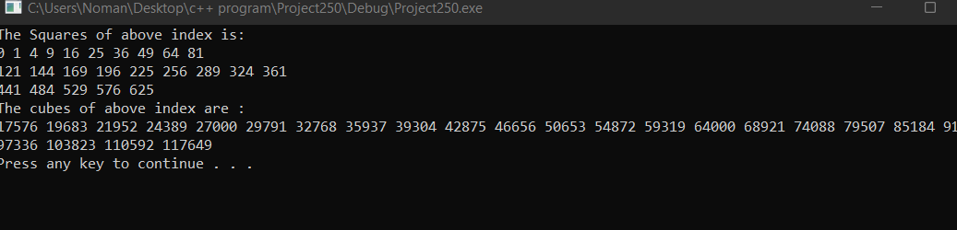

Question #2:

#include<iostream>

using namespace std;

int main()

{

cout << " Intersection of two arrays is: " << endl;

int arrA[4] = { 5,15,32,69 }; //Taking arrays and intializing them//

int arrB[2] = { 7,69 };

int arrC[1];

int arrD[5] = { 0 };

int arr5[6] = { 0 };

for (int i = 0; i < 4; i++)

{

for (int j = 0; j < 2; j++)//printing Union //

{

if (arrA[i] == arrB[j])//condition for intersection//

{

arrC[0] = arrB[j];

cout << arrC[0];

}

}

}

for (int a = 0; a < 4; a++)

{

arr5[a] = arrA[a];

}

int f = 0;

for (int a = 4; a < 6; a++)

{

arr5[a] = arrB[f];

f++;

}

for (int a = 0; a < 6; a++)

{

if (arr5[a] != arrC[0])

{

int store = arrD[a] = arr5[a];

}

}

arrD[3] = arrC[0];

cout << endl;

cout << "the union of the two arrays " << endl;

for (int a = 0; a < 5; a++) //Displaying the union//

{

cout << arrD[a];

cout << " ";

}

system("pause");

return 0;

}

Output:

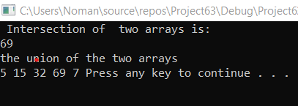

Question #4:

#include<iostream>

#include<string>

using namespace std;

int main()

{

string arr[5]; /*Here we are taking an array of Type String*/

int arrvotes[5]; /*Here we are Taking array for Number of Votes*/

cout << "Enter the last Five Names of Canidates : ";/* taking Input*/

for (int i = 0; i < 5; i++)

{

cin >> arr[i];

}

cout << "Enter the Number of Votes of each canidate : "; /*Taking Input for Number of Votes */

for (int j = 0; j < 5; j++)

{

cin >> arrvotes[j];

}

double sum = 0.0, percentage = 0.0;

for (int j = 0; j < 5; j++) /*calculating sum for finding %*/

{

sum += arrvotes[j];

}

cout << "canidates\tvotes received\t% of total votes" << endl;

for (int i = 0; i < 5; i++)

{

percentage = (arrvotes[i] / sum) * 100;

cout << arr[i]<<"\t\t\t"<<arrvotes[i]<<"\t\t\t"<< percentage<<endl;

}

int larger= 0;

for (int j = 0; j < 5; j++) /*Finding the larger votes in the array */

{

if (arrvotes[j] > larger)

{

larger = arrvotes[j];

}

}

cout << "The Winner is " << "Duffy"<< endl;

system("pause");

return 0;

}

Output:

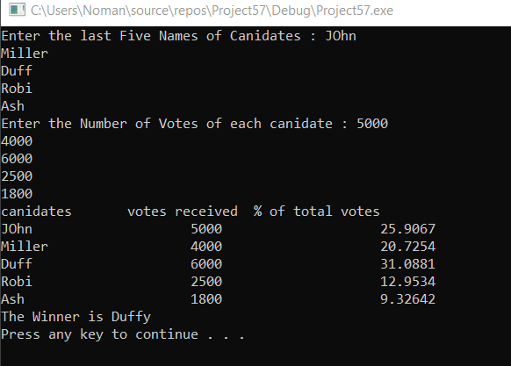

Question #5:

#include<iostream>

#include<string>

using namespace std;

int main()

{

double avg = 0, sum = 0;/* Intializing some variables*/

double arr[5][7]; /*Taking array*/

string arr1[5];

char option;

cout << "if you want to store the runner name and their distance covered press y/Y:";

cin >> option;

if (option == 'Y' || option == 'y') /*User's Option Method*/

{

for (int i = 0; i < 5; i++) /*taking Runner Name*/

{

cout << "Enter runner " << i + 1 << " Name: ";

cin >> arr1[i];

for (int j = 0; j < 7; j++) /*taking Miles of each runner */

{

cout << "Enter this user miles run: ";

cin >> arr[i][j];

}

}

}

cout << "if you want to find the sum and the average miles run by each runner press y/Y:";

cin >> option;

if (option == 'y' || option == 'Y')

{

system("cls");

for (int i = 0; i < 5; i++) /*Finding sum and average of each runner*/

{

sum = 0; avg = 0;

for (int j = 0; j < 7; j++)

{

sum += arr[i][j];

}

cout << "Sum of miles run by " << arr1[i] << " is " << sum; /*displaying sum of Miles */

avg = sum / 7;

cout << " and his average is :" << avg << endl; /*Displaying Average */

}

}

system("pause");

return 0;

}

Output:

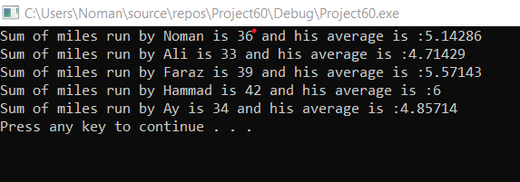

Question #6:

#include<iostream>

#include<string>

using namespace std;

int main()

{

char arr[13][6]; // character array of 13*6

int row_no = 1, seat_no; // Variable for displaying Row numbers

string seat_type; // variable that takes seat type

for (int i = 0; i < 13; i++) // for loop for assigning loop with *

{

for (int j = 0; j < 6; j++)

arr[i][j] = '*';

}

// disolaying initial information

cout << endl << endl << "Row No\t\t\t\t\t------------Plane Seat Reservation Program------------" << endl << endl;

for (int i = 0; i < 13; i++) // for loop thst display Seats

{

cout << row_no << "\t\t\t\t\t";

row_no++;

for (int j = 0; j < 6; j++)

{

cout << arr[i][j] << "\t";

}

cout << endl << endl;

}

do

{

cout << "\t\t\t\t\tYou have First class Seats (Row 1-2) business classlseat(Row 3 - 7) Economy class seats(Row 8 - 13)" << endl << "\t\t\t\t\t Each row Contain 6 seats" << endl << "\t\t\t\t\t * indicates seat is available X indicates seat is reserved" << endl;

cout << "\t\t\t\t\tEnter your seat type for first class enter 'first class' for business class enter 'business class' for economy class enter 'economy class' to quite program enter quite" << endl;

getline(cin, seat_type);

if (seat_type == "first class") // if condition that manages first class seats

{

cout << "\t\t\t\t\tYou have Row1 to Row2 of seats enter Row No.";

cin >> row_no;

cout << "\t\t\t\t\tEnter your seat No.";

cin >> seat_no;

arr[row_no][seat_no] = 'X';

}

if (seat_type == "business class") // if condition that manages business class seats

{

cout << "\t\t\t\t\tYou have Row3 to Row7 of seats enter Row No.";

cin >> row_no;

cout << "\t\t\t\t\tEnter your seat No.";

cin >> seat_no;

arr[row_no][seat_no] = 'X';

}

if (seat_type == "economy class") // if condition that economy first class seats

{

cout << "\t\t\t\t\tYou have Row8 to Row13 of seats enter Row No.";

cin >> row_no;

cout << "\t\t\t\t\tEnter your seat No.";

cin >> seat_no;

arr[row_no][seat_no] = 'X';

}

row_no = 1;

system("cls");

for (int i = 0; i < 13; i++) // for loop thst display Seats after reserving seats

{

cout << row_no << "\t\t\t\t\t";

row_no++;

for (int j = 0; j < 6; j++)

{

cout << arr[i][j] << "\t";

}

cout << endl << endl;

}

} while (seat_type != "quite");

system("pause");

return 0;

}

Output:

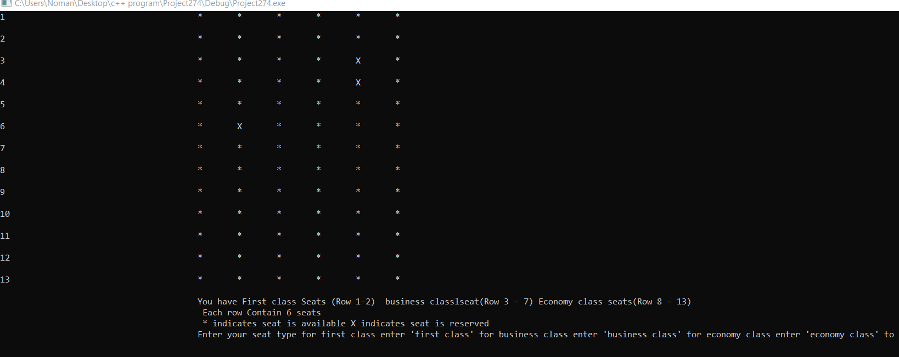

Question #7:

#include<iostream>

#include<ctime>

using namespace std;

int main()

{

int arr[9][9];

srand(time(0));

for (int i = 0; i < 9; i++)//Generating Random Number //

{

for (int j=0;j<9;j++)

arr[i][j] = ( rand() % 9) + 1;

}

//printing random number //

for (int i = 0; i < 9; i++)

{

for (int j = 0; j < 9; j++)

{

arr[i][j] = (rand() % 9) + 1;

cout << arr[i][j] << " ";

}

cout << endl;

}

cout << endl;

for (int i = 0; i < 3; i++) //intializing with zero Left first three rows and columns //

{

for (int j = 0; j < 3; j++)

arr[i][j] = 0;

}

for (int i = 0; i < 3; i++)//right Last Three index intializing//

{

for (int j = 6; j < 9; j++)

arr[i][j] = 0;

}

for (int i = 6; i < 9; i++) //same Here //

{

for (int j = 0; j < 3; j++)

arr[i][j] = 0;

}

for (int i = 6; i < 9; i++)

{

for (int j = 6; j < 9; j++)

arr[i][j] = 0;

}

for (int i = 0; i < 9; i++)// Displaying random number//

{

for (int j = 0; j < 9; j++)

{

if (arr[i][j] == 0)

cout << " ";

else

cout << arr[i][j] << " ";

}

cout << endl;

}

system("pause");

return 0;

}

Output:

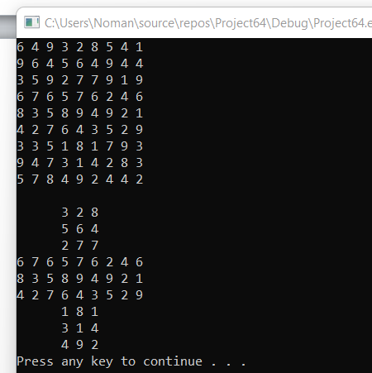

Question 8:

#include<iostream>

using namespace std;

int main()

{

int arr[10] = { 0,1,0,0,1,1,1,0,1,0 };/*Intializeing arry of size 10*/

int temp = 0;

for (int i = 0; i < 10; i++)

{

for (int j = 0; j < 9; j++)/* This for Loop will compare Number */

{

if (arr[j+1]<arr[j]) /*This is the condition for sorting array */

{

temp = arr[j + 1]; /*swapping variables*/

arr[j + 1] = arr[j];

arr[j] = temp;

}

}

}

cout << "The sorted array is " << endl;

for (int i = 0; i < 10; i++) /* Displaying the sorted array */

{

cout << arr[i] << " ";

}

system("pause");

return 0;

}

Output:

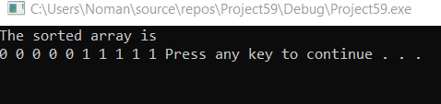

Output:

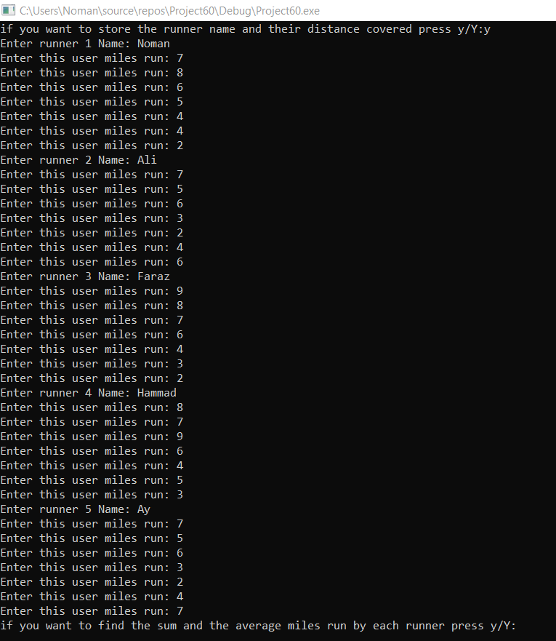

Question #9:

#include<iostream>

using namespace std;

int main()

{

const int n = 3;

const int m = 4;

int arr[n][m];

int row_start = 0, row_end =n-1, col_start = 0, col_end =m-1; //Intializing some variables//

cout << "Enter the elements of the array : ";

cout << endl;

for (int i = 0; i < 3; i++) //taking input//

{

for (int j = 0; j < 4; j++)

{

cin >> arr[i][j];

}

}

while (row_start<=row_end&&col_start<=col_end)

{

for (int col = col_start; col <= col_end; col++)//for row start//

cout << arr[row_start][col] << " ";

row_start++;

for (int row = row_start; row <= row_end; row++)//for column end//

cout << arr[row][col_end] << " ";

col_end--;

for (int col = col_end; col >= col_start; col--)//for row end//

cout << arr[row_end][col] << " ";

row_end--;

for (int row = row_end; row >= row_start; row--) //for column start//

{

cout << arr[row][col_start] << " ";

}

col_start++;

}

system("pause");

return 0;

}

Output:

